**“HYBRID MEETING via TEAMS (not official guidance)”**

* log in with your own details on the PC in the room (remember to use your [UUN@ed.ac.uk](mailto:UUN@ed.ac.uk) (moderator or host should always login onto main Wellcome Theatre computer)
* always use Microsoft Chrome
* open your Teams meeting via link (if unable to find TEAMS - search under spy 🕵️‍♀️ loop button
* use the touch pad that sits to the left of the PC.  Touch it to turn it on and then make sure that the input is set to PC and the projector is switched on. (note: your screen can be seen by the audience!)
* tap SHOW SCREEN and the image from the PC screen should appear on the big screen.  It displays a yellow box around the button when it's projecting.  Just touch it again to remove the projection to the big screen.
* The camera mounted on an angle poise stand can be turned to point it at the audience or the speaker.

**“Using a PC laptop or mac for presentation”**

The computer will be on even if you don’t login. So …

* You can just plug in your laptop to the VGA or HDMI connection and not have the main computer doing anything. It will be on though, and so your voice will be heard IF YOU SWITCH ON AND USE THE LAPEL MIKE
* Select laptop on the pad (rather than PC) and you should see your laptop screen on screen
* The room is enabled for 'Hybrid' audio - that means the output from the room microphones (the lapel mics and the handheld mics) now also go into the PC and can be seen by online meeting apps like Teams and Zoom. You just need to make sure that you select 'Line In' for your microphone within those Apps when you configure your audio setup at the start
* Switch off microphone input on your laptop (microphone) - when questions arise, make sure the speakers on the laptop are on top level as then room will hear the TEAMS chat in the auditorium better.
* DO NOT SHARE MICROPHONES AT THIS COVID TIME there are some 'push to talk' mobile microphones that can be used for audience participation while wearing a mask. There are six of them and they can be found on the front desk and will usually be sat on their charging pads. If you have a meeting that requires audience participation, place the mics on the trolleys around the auditorium and users can walk to the nearest mic and press RED square button and use it when the light turns to GREEN, audience can contribute and have their audio heard by the remote audience.

**“HOW TO OPERATE MICs”**

* Lapel ones need turned on (switch is under flap with batteries in). The put on and make sure its not on mute.
* 'push to talk' mobile microphones You just need to press the 'talk' button for a couple of seconds to turn them on, flashing red: pairing

Solid red: ready

Press again

Green: “live” (projecting your voice).

Once finished, you can switch them off by holding down the talk button for a couple of seconds.

* Any questions raised by the audience MUST be repeated by the lecturer for the online attendees as they cannot hear these clearly enough.
* Since recently the audio in the room had been adjusted on a higher output level for online audience to hear, and it works much better.

**“Add a second device to a meeting”**

While you're in a meeting on one device eg. the main computer, open Teams on the second one. You'll see a message near the top of your screen informing you that you're currently in a meeting on another device, and asking if you want to join it on this one, too.

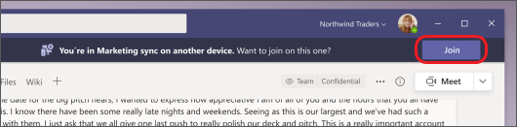

Select Join.

You'll then see two options: Add this device, and Transfer to this device.

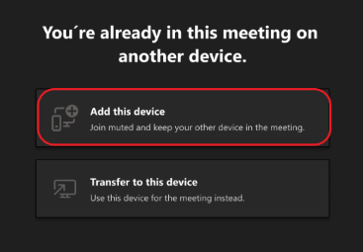

Select Add this device.

Teams will automatically mute the mic on your second device before it enters the meeting to prevent an echo effect. Once it's joined, you'll be able to turn the mic and camera on or off as needed.

With both devices in the meeting, you can now share content from either one.

**“Hosting a webinar on TEAMS”**

* Go to your calendar of TEAMS and then click on the “New Meeting” top right hand corner – click on down arrow and click on “Webinar” option.
* Fill in the date and time of your event, as well as whether it will be recurring.
* Put in presenter’s details
* SAVE
* New link will be created – use this link to send out invitation for people to attend

**“Uploading speaker’s presentation”**

* Speaker’s presentation to be on USB for transfer, or onto TEAMS for upload
* Speakers can login with their TEAMS credentials and share content - via other account (external person)
* Two people should have overall control of the meeting (host and moderator)
* Use blank projector page while setting things up on the main computer. Use touch pad to swap the source not to have projection active while setting up.

**“To share the talk”**

* Click on filename listed in TEAMS
* Open PPT on a computer and project it, then go in TEAMS and share the “window” that shows presentation rather than “share screen”

**“Record WEBINAR on TEAMS”**

* Start or join the meeting.
* Go to the meeting controls and select **More actions** More options button > **Start recording**

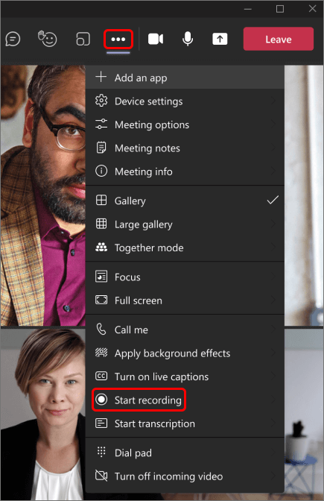

* Everyone in the meeting gets notified that recording and transcription have started
* **Stop recording**: stops the recording and live transcription.
* **Stop transcription**:stops just the live transcription. The recording continues until you select **Stop recording**.
* Recording will automatically be saved under “Files” in TEAM Meeting in Calendar: link can be copied and save into “CVS Seminar Series”